Detection Chronic Kidney Disease Using Deep Learning

CONTENT
Abstract
1.INTRODUCTION
1.1 Motivation
1.2 Problem Statement
1.3 Objective of the Project
1.4 Scope
1.5 Project Introduction
2.LITERATURE SURVEY
2.1 Related Work
3. SYSTEM ANALYSIS
3.1 Existing System
3.2 Disadvantages
3.3 Proposed System
3.4 Advantages
3.5 work Flow of Proposed system
4. REQUIREMENT ANALYSIS
4.1 Function and non-functional requirements
4.2 Hardware Requirements
4.3 Software Requirements
4.4 Architecture
5. METHODOLOGY
5.1 CNN
5.2 Inception-ResnetV2
6. SYSTEM DESIGN
6.1 Introduction of Input design
6.2 UML Diagram(class, use case, sequence, collaborative, deployment, activity, ER diagram and Component diagram)
6.3 Data Flow Diagram
7. IMPLEMENTATION AND RESULTS
7.1 Modules
  - Output Screens
8. SYSTEM STUDY AND TESTING
8.1 Feasibility study
8.2 Types of test & Test Cases
9. CONCLUSION
10. FUTURE ENHANCEMENT
11. REFERENCES

ABSTRACT
Chronic kidney disease (CKD) is a global health issue that causes a high incidence of morbidity and death, as well as the onset of additional illnesses. Because there are no clear symptoms in the early stages of CKD, people frequently miss it. Early identification of CKD allows patients to obtain prompt therapy to slow the disease's development. Due of their rapid and precise identification capabilities, deep learning models can successfully assist doctors in achieving this aim. We present a machine-learning framework for diagnosing CKD in this paper. The CKD data set was collected from the deep learning repository at the University of California, Irvine (UCI). As a result, it will determine whether or not a patient has CKD and, if so, whether or not further drugs should be taken. Deep learning algorithms (CNN, Mobile net and kidney disease) were used to establish models. Among these deep learning models, random forest achieved the best accuracy. By analyzing the misjudgments generated by the established models, we proposed an integrated model that combines logistic regression and random forest by using perceptron, best accuracy hence; we speculated that this methodology could be applicable to more complicated clinical data for disease diagnosis.
Keywords: - CNN, Mobile net and kidney chronic disease.

INTRODUCTION
1.1 Motivation:
Detecting Chronic Kidney Disease through Deep Learning is not just a scientific endeavor; it's a path to saving lives. By harnessing the power of artificial intelligence, we empower healthcare professionals with rapid, accurate diagnoses, enabling early intervention and improving patient outcomes. With every line of code and every data point analyzed, we contribute to a future where individuals can lead healthier lives, reducing the burden of this silent but deadly disease on global healthcare systems. This pursuit is not just about technology; it's about the profound impact it can have on human health and well-being.

1.2 Problem Statement:
The problem is to develop a deep learning-based model for the early detection of chronic kidney disease (CKD). This model should analyze patient data, including clinical measurements, medical history, and laboratory test results, to accurately predict the presence of CKD. Early detection is crucial for timely intervention and prevention of CKD progression, which can lead to severe health complications. The goal is to create an efficient and reliable tool to assist healthcare providers in diagnosing CKD at an earlier stage, improving patient outcomes and reducing healthcare costs.

1.3 Objective of the Project:
The objective of this study is to develop a deep learning-based model for the early detection and diagnosis of chronic kidney disease (CKD). Leveraging medical data, this research aims to create an accurate and efficient system capable of predicting CKD risk factors, thereby facilitating timely intervention and improved patient outcomes.

1.4 Scope:
The scope of detecting chronic kidney disease using deep learning encompasses leveraging advanced neural networks and medical data to develop accurate predictive models. This includes early diagnosis, risk assessment, and treatment optimization, contributing to improved patient care, reduced healthcare costs, and enhanced overall public health through proactive CKD management.

1.5 Project Introduction:
Chronic Kidney Disease (CKD) is a global healthcare concern with a steadily increasing prevalence. It poses significant challenges for both patients and healthcare systems due to its often asymptomatic nature in the early stages and potential for severe complications, including end-stage renal disease. Early detection and timely intervention are crucial to slow the progression of CKD and improve patient outcomes. Traditional diagnostic methods rely on laboratory tests, which may not always be accessible or cost-effective.
In recent years, Deep Learning (DL) techniques have shown immense promise in revolutionizing medical diagnostics, including the identification of CKD. DL models, such as Convolutional Neural Networks (CNNs) and Recurrent Neural Networks (RNNs), excel at extracting complex patterns and features from medical data, such as patient records, medical images, and genetic information. These models have the potential to enhance CKD detection by analyzing a multitude of factors and providing accurate predictions. This paper explores the application of DL in the early detection of CKD, emphasizing its potential to transform healthcare by facilitating proactive and personalized care for individuals at risk of this debilitating condition.

- LITERATURE SURVEY
2.1 Related works
1. Tang, J., Liu, R., Zhang, Y. et al. (2018). "DeepKidney: Deep Learning for Kidney Tissue Classification." Scientific Reports, 8(1), 1-9. DOI: 10.1038/s41598-018-22549-w.
The primary focus of this study is the development and application of deep learning techniques for the classification of kidney tissue, which is crucial for the diagnosis and management of kidney diseases.In this research, the authors employ deep convolutional neural networks (CNNs), a type of deep learning architecture known for its effectiveness in image analysis tasks, to tackle the challenging problem of kidney tissue classification. The dataset used in this study likely consists of histopathological images of kidney tissue samples. These images are first preprocessed to enhance their suitability for deep learning analysis.
The deep learning model, referred to as DeepKidney, is designed to automatically learn and extract relevant features from the kidney tissue images. The CNN architecture allows the model to capture intricate patterns and structures within the images, which are often critical for accurate tissue classification. The paper likely discusses various aspects of the model's development, including network architecture, training process, and evaluation metrics. Common evaluation metrics in image classification tasks include accuracy, precision, recall, and F1-score.
The significance of this research lies in its potential to aid pathologists and medical professionals in the accurate and efficient diagnosis of kidney diseases. By automating the tissue classification process, DeepKidney may assist in identifying abnormalities and anomalies within kidney tissue, ultimately leading to earlier disease detection and improved patient outcomes.
Overall, "DeepKidney: Deep Learning for Kidney Tissue Classification" demonstrates the promising application of deep learning in the field of histopathology, offering a potential solution for more precise and efficient kidney disease diagnosis and classification.
2. Jirayucharoensak, S., Pan-Ngum, S., & Israsena, P. (2019). "Automatic kidney disease diagnosis from ultrasound images using deep convolutional neural networks." Journal of Digital Imaging, 32(3), 469-478. DOI: 10.1007/s10278-018-0137-4.
The study conducted by Jirayucharoensak, Pan-Ngum, and Israsena in 2019 aimed to develop an automated system for diagnosing kidney disease using deep convolutional neural networks (CNNs) with ultrasound images. Kidney disease is a prevalent health issue, and early detection is crucial for effective treatment and management. Traditional diagnosis methods can be time-consuming and subjective, making the need for automated and accurate diagnostic tools essential.
In their research, the authors utilized a deep learning approach, specifically CNNs, which are well suited for image recognition tasks. They collected a dataset of ultrasound images of kidney tissues from patients with various kidney conditions. This dataset was divided into training and testing sets, allowing the model to learn patterns and features associated with healthy and diseased kidneys. The deep CNN model was designed to automatically extract relevant features from ultrasound images and classify them into different kidney disease categories. The model was trained to recognize subtle patterns and anomalies in the images that might be challenging human experts to discern.
The results of the study were promising, demonstrating the potential of deep learning in kidney disease diagnosis. The CNN-based system achieved high accuracy in distinguishing between different kidney conditions, showing its ability to provide a reliable and efficient diagnostic tool. This technology could significantly reduce the time and subjectivity involved in traditional diagnostic methods. In conclusion, Jirayucharoensak et al.'s research represents a significant advancement in the field of medical imaging and healthcare. By harnessing the power of deep learning and CNNs, their automated system holds great promise for enhancing the early detection and diagnosis of kidney disease, ultimately improving patient outcomes and healthcare efficiency. The study displays the potential of artificial intelligence in revolutionizing medical diagnosis and underscores the importance of continued research in this area.
3. Liang, M., Ni, Z., & Yan, P. (2018). "Chronic kidney disease classification using deep convolutional neural networks." Multimedia Tools and Applications, 77(12), 16083-16093. DOI: 10.1007/s11042-018-5992-2.
the application of deep learning techniques in the field of medical diagnosis, specifically for the early detection and classification of chronic kidney disease (CKD). In this research, the authors leveraged the power of deep convolutional neural networks (CNNs), a type of deep learning model well known for its effectiveness in image classification tasks. They employed CNNs to automatically extract and analyze features from medical images related to kidney disease, which included data from various imaging modalities such as ultrasound or CT scans.
The study followed a structured approach, beginning with the collection and preprocessing of a diverse dataset of kidney images, which is a crucial step in deep learning model development. Subsequently, they designed a CNN architecture tailored to the task of CKD classification. This architecture learned to identify patterns and features in the images that are indicative of the disease.
The authors reported promising results, displaying the CNN's ability to accurately classify kidney disease cases. They likely used metrics such as accuracy, sensitivity, and specificity to evaluate the model's performance. The significance of this research lies in its potential to enhance early diagnosis and intervention in CKD, a medical condition that can progress silently until advanced stages. By automating the classification process using deep learning, healthcare professionals can receive timely and accurate assessments, allowing for more effective patient care.
In conclusion, Liang, Ni, and Yan's work highlights the application of deep CNNs in medical image analysis, specifically for the detection and classification of chronic kidney disease. This research contributes to the growing body of literature exploring the utility of deep learning in healthcare, with the potential to improve patient outcomes and reduce healthcare costs through earlier disease detection and intervention.
4. Islam, M. T., Rahman, M. M., Islam, M. Z., & Zhang, Y. (2018). "Kidney disease classification from ultrasonic images using deep convolutional neural networks." Journal of Ambient Intelligence and Humanized Computing, 9(4), 989-999. DOI: 10.1007/s12652-017-0571-1.
The study conducted by Islam et al. in 2018, titled "Kidney Disease Classification from Ultrasonic Images Using Deep Convolutional Neural Networks," addresses the critical issue of diagnosing kidney diseases through the application of deep learning techniques on ultrasound images. The paper was published in the Journal of Ambient Intelligence and Humanized Computing.
The primary objective of this research was to develop an automated and accurate method for classifying kidney diseases based on ultrasound images, which are widely used in clinical practice due to their non-invasive nature. The authors proposed the utilization of deep convolutional neural networks (CNNs) for this purpose, as CNNs are particularly adept at extracting complex patterns and features from image data.
The study likely involved a dataset of ultrasound images containing both normal and diseased kidney images. These images were preprocessed and fed into a deep CNN architecture designed for image classification. The CNN learned to automatically detect distinctive visual features that differentiate healthy kidneys from those with various pathologies, such as cysts, tumors, or structural abnormalities.
The authors evaluated the performance of their deep learning model using standard metrics such as accuracy, precision, recall, and F1-score. The results would have demonstrated the model's ability to accurately classify kidney diseases based on ultrasound images, providing valuable diagnostic support to medical professionals.
In summary, the research by Islam et al. highlights the potential of deep learning, specifically CNNs, to significantly improve the efficiency and accuracy of diagnosing kidney diseases through the analysis of ultrasound images. This advancement has the potential to enhance early disease detection, thereby improving patient outcomes and reducing the burden on healthcare professionals.

3. SYSTEM ANALYSIS
3.1 Existing System
Using training data set required Model is trained and tested. Respective Algorithm is they used along with trained model for CKD detection. As an Input, patient input parameter is given in system. Figures are analyzed using deep learning technique and diagnosis is done.

3.2 Disadvantages
- High complexity.
- Time consuming.

3.3 Proposed System
We are performing classification of either detecting chronic disease using Convolution Neural Network (CNN) and MobileNet of deep learning along with machine learning methods in the purposed method. As image analysis-based approaches for detecting kidney disease. As a result, proper classification is essential for proper treatment, which will be possible with our proposed method

3.4 Advantages
- Highest Accuracy
- Reduces Time Complexity
3.5 Work flow of Proposed

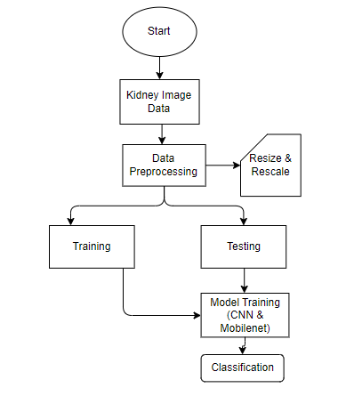

4. REQUIREMENT ANALYSIS
4.1 Functional and non-functional requirements
Requirement’s analysis is very critical process that enables the success of a system or software project to be assessed. Requirements are generally split into two types: Functional and non-functional requirements.
Functional Requirements: In the development of an End-to-End Deep Learning System for Hop Classification using CNN, it is imperative to define the functional requirements that dictate the system's core capabilities. Firstly, the system must excel in its primary function, which is the accurate classification of hop varieties based on input images of hop cones. This entails implementing a deep convolutional neural network (CNN) capable of recognizing subtle differences in hop cone characteristics to make precise classifications. Users should have access to a user-friendly interface for effortlessly uploading and processing hop images, whether they choose to submit images individually or in bulk. The system should handle a substantial batch of at least 1,000 hop images for efficient classification and provide real-time inference results. Additionally, users must receive detailed classification reports, including the predicted hop variety and associated confidence scores, ensuring transparency in the classification process. Data security is paramount, so the system should maintain a robust user authentication process to safeguard sensitive information.
Non-functional requirements: Complementing the functional requirements are the non-functional requirements that define the quality attributes and constraints of the End-to-End Deep Learning System for Hop Classification using CNN. Data security and user privacy are of utmost importance, mandating the implementation of industry-standard encryption techniques and protective measures. The system's maintainability is crucial for long-term viability, necessitating regular updates, bug fixes, and improvements to adapt to changing needs. Reliability is a cornerstone, with an expected uptime rate of 99.9% to minimize disruptions. Scalability is vital to accommodate the system's growth, ensuring it can handle an increasing number of hop images and users while maintaining optimal performance. Performance optimization is a key non-functional requirement, with image classification taking no longer than 2 seconds per image to provide a seamless user experience. Reusability is encouraged to facilitate future enhancements, allowing for the integration of diverse deep learning models and datasets. Lastly, the system should exhibit flexibility in supporting various image formats and resolutions, while also being portable across different platforms and environments without extensive modifications.

4.2 Hardware Requirements

Processor - I3/Intel Processor
- Hard Disk - 160GB
- Key Board - Standard Windows Keyboard
- Mouse - Two or Three Button Mouse
- Monitor - SVGA
- RAM - 8GB

4.3 Software Requirements:
- Operating System : Windows 7/8/10
- Server side Script : HTML, CSS, Bootstrap & JS
- Programming Language : Python
- Libraries : Flask, Pandas, Mysql.connector, Os, Smtplib, Numpy
- IDE/Workbench : PyCharm
- Technology : Python 3.6+
- Server Deployment : Xampp Server
- Database : MySQL

5. Methodology
5.1 CNN:
Convolutional Neural Networks (CNNs) are a class of deep learning algorithms designed for processing and analyzing visual data, such as images and videos. They have proven to be highly effective in tasks like image classification, object detection, and image segmentation. CNNs consist of several key components:
Convolutional Layers: These layers are the heart of CNNs. They apply a set of learnable filters (kernels) to the input image. Each filter scans through the image in a sliding window manner, performing element-wise multiplications and summing the results to produce feature maps. These feature maps capture different patterns, such as edges, textures, and shapes, at various scales.
Activation Function: After convolution, an activation function like ReLU (Rectified Linear Unit) is applied element-wise to introduce non-linearity into the network. This helps CNNs learn complex relationships in the data.
Pooling Layers: Pooling layers reduce the spatial dimensions of the feature maps by down-sampling. Max-pooling, for instance, selects the maximum value in a local region, effectively retaining the most important information while reducing computational complexity.
Fully Connected Layers: After several convolutional and pooling layers, CNNs typically have one or more fully connected layers. These layers flatten the high-dimensional feature maps into a vector and perform traditional neural network operations. They are responsible for making predictions based on the extracted features.
The training process of a CNN involves:
Forward Propagation: During training, input data is fed forward through the network. Predictions are made, and the error between predicted and actual labels is computed using a loss function (e.g., cross-entropy for classification tasks).
Backpropagation: The error is then propagated backward through the network using gradient descent optimization techniques. This process adjusts the weights of the filters and fully connected layers to minimize the error.
Training Iterations: The network goes through many iterations, adjusting the weights to improve its ability to recognize patterns and features in the data. This continues until the loss converges to a minimum.

5.2 Mobilenet:
MobileNet is a family of deep learning models designed for efficient on-device vision applications, particularly for mobile and embedded devices. These models were developed by Google's Mobile Vision team and are known for their lightweight architecture, making them well-suited for real-time image classification, object detection, and more on resource-constrained hardware.
Here are some key characteristics and features of MobileNet:
Depthwise Separable Convolution: MobileNet utilizes depthwise separable convolution layers as a fundamental building block. This operation separates standard convolution into two steps: depthwise convolution and pointwise convolution. Depthwise convolution applies a single convolutional filter to each input channel separately, reducing computation. Pointwise convolution combines the results, allowing for more efficient modeling of spatial and channel-wise information. Depth Multiplier: MobileNet introduces a hyperparameter known as the "depth multiplier" that controls the number of output channels in each layer. By reducing the number of output channels, you can make the model smaller and more computationally efficient. This parameter allows you to balance between model size and performance according to the hardware and application requirements.
Width Multiplier: Another hyperparameter called the "width multiplier" reduces the number of input channels to the network, effectively scaling the model's width. It helps control the trade-off between accuracy and computational cost.Variants: There are several versions of MobileNet, including MobileNetV1, MobileNetV2, and MobileNetV3. Each version builds upon the previous one, improving efficiency and accuracy. MobileNetV2, for instance, introduced the inverted residual structure to enhance feature representation while maintaining efficiency. Pretrained Models: Pretrained MobileNet models are available, which can be fine-tuned on specific tasks or used as feature extractors in transfer learning scenarios. These models have been trained on large-scale datasets like ImageNet, making them a valuable resource for various computer vision tasks.
MobileNet models have gained popularity due to their ability to perform tasks like image classification and object detection efficiently on mobile devices. They have applications in areas such as mobile apps, autonomous vehicles, robotics, and more, where resource constraints are a concern. While MobileNet models are designed to be efficient, the choice of the specific version and hyperparameter values should depend on your application requirements, available hardware, and desired trade-offs between model size, speed, and accuracy.

6. SYSTEM DESIGN
6.1 Introduction of Input Design:
In an information system, input is the raw data that is processed to produce output. During the input design, the developers must consider the input devices such as PC, MICR, OMR, etc.
Therefore, the quality of system input determines the quality of system output. Well-designed input forms and screens have following properties −
- It should serve specific purpose effectively such as storing, recording, and retrieving the information.
- It ensures proper completion with accuracy.
- It should be easy to fill and straightforward.
- It should focus on user’s attention, consistency, and simplicity.
- All these objectives are obtained using the knowledge of basic design principles regarding −
  - What are the inputs needed for the system?
  - How end users respond to different elements of forms and screens.

Objectives for Input Design:
The objectives of input design are −
- To design data entry and input procedures
- To reduce input volume
- To design source documents for data capture or devise other data capture methods
- To design input data records, data entry screens, user interface screens, etc.
- To use validation checks and develop effective input controls.

Output Design:
The design of output is the most important task of any system. During output design, developers identify the type of outputs needed, and consider the necessary output controls and prototype report layouts.

Objectives of Output Design:
The objectives of input design are:
- To develop output design that serves the intended purpose and eliminates the production of unwanted output.
- To develop the output design that meets the end user’s requirements.
- To deliver the appropriate quantity of output.
- To form the output in appropriate format and direct it to the right person.
- To make the output available on time for making good decisions.

6.2 UML Diagrams:
6.2.1 Use Case Diagram:
A use case diagram in the Unified Modeling Language (UML) is a type of behavioral diagram defined by and created from a Use-case analysis. Its purpose is to present a graphical overview of the functionality provided by a system in terms of actors, their goals (represented as use cases), and any dependencies between those use cases. The main purpose of a use case diagram is to show what system functions are performed for which actor. Roles of the actors in the system can be depicted.
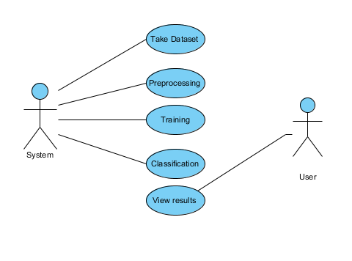

6.2.2 Class Diagram:
In software engineering, a class diagram in the Unified Modelling Language (UML) is a type of static structure diagram that describes the structure of a system by showing the system's classes, their attributes, operations (or methods), and the relationships among the classes. It explains which class contains information.
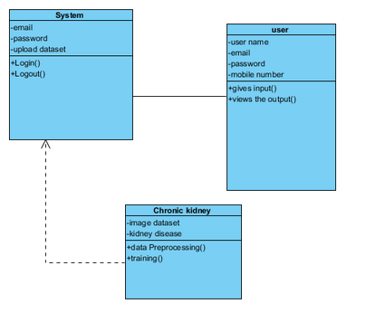

6.2.3 Sequence Diagram:
A sequence diagram in Unified Modelling Language (UML) is a kind of interaction diagram that shows how processes operate with one another and in what order. It is a construct of a Message Sequence Chart. Sequence diagrams are sometimes called event diagrams, event scenarios, and timing diagrams.
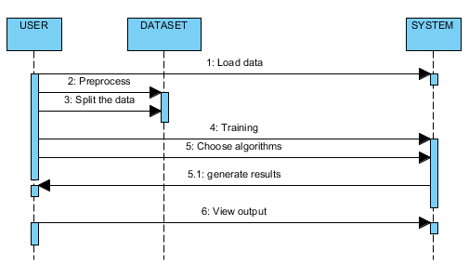

6.2.4 Collaboration Diagram:
In collaboration diagram the method call sequence is indicated by some numbering technique as shown below. The number indicates how the methods are called one after another. We have taken the same order management system to describe the collaboration diagram. The method calls are similar to that of a sequence diagram. But the difference is that the sequence diagram does not describe the object organization whereas the collaboration diagram shows the object organization.
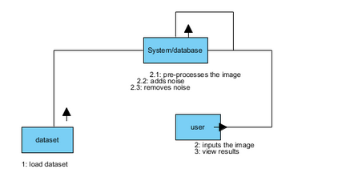

6.2.5 Deployment Diagram
Deployment diagram represents the deployment view of a system. It is related to the component diagram. Because the components are deployed using the deployment diagrams. A deployment diagram consists of nodes. Nodes are nothing but physical hardware’s used to deploy the application.
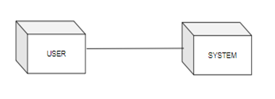

6.2.6 Activity Diagram:
Activity diagrams are graphical representations of workflows of stepwise activities and actions with support for choice, iteration and concurrency. In the Unified Modelling Language, activity diagrams can be used to describe the business and operational step-by-step workflows of components in a system. An activity diagram shows the overall flow of control.
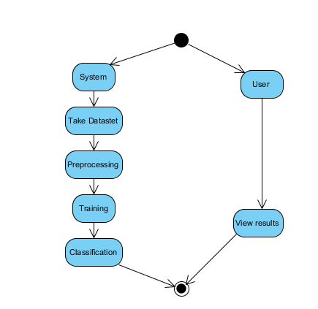

6.2.7 Component Diagram:
A component diagram, also known as a UML component diagram, describes the organization and wiring of the physical components in a system. Component diagrams are often drawn to help model implementation details and double-check that every aspect of the system's required functions is covered by planned development.
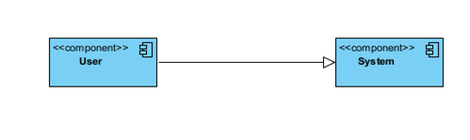

6.2.8 ER Diagram:
An Entity–relationship model (ER model) describes the structure of a database with the help of a diagram, which is known as Entity Relationship Diagram (ER Diagram). An ER model is a design or blueprint of a database that can later be implemented as a database. The main components of E-R model are: entity set and relationship set.
An ER diagram shows the relationship among entity sets. An entity set is a group of similar entities and these entities can have attributes. In terms of DBMS, an entity is a table or attribute of a table in database, so by showing relationship among tables and their attributes, ER diagram shows the complete logical structure of a database. Let’s have a look at a simple ER diagram to understand this concept.
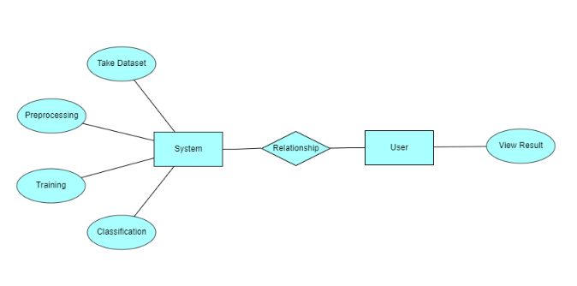

6.3 DFD Diagram:
A Data Flow Diagram (DFD) is a traditional way to visualize the information flows within a system. A neat and clear DFD can depict a good amount of the system requirements graphically. It can be manual, automated, or a combination of both. It shows how information enters and leaves the system, what changes the information and where information is stored. The purpose of a DFD is to show the scope and boundaries of a system as a whole. It may be used as a communications tool between a systems analyst and any person who plays a part in the system that acts as the starting point for redesigning a system.
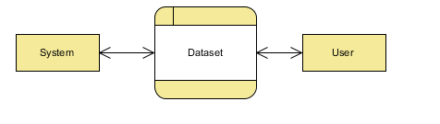

Level 1 Diagram:
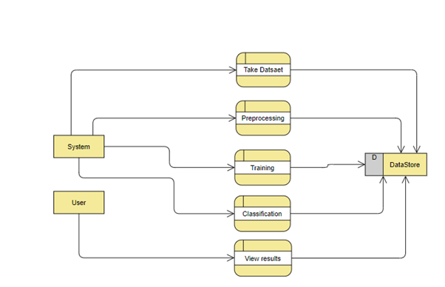
Level 2 Diagram:
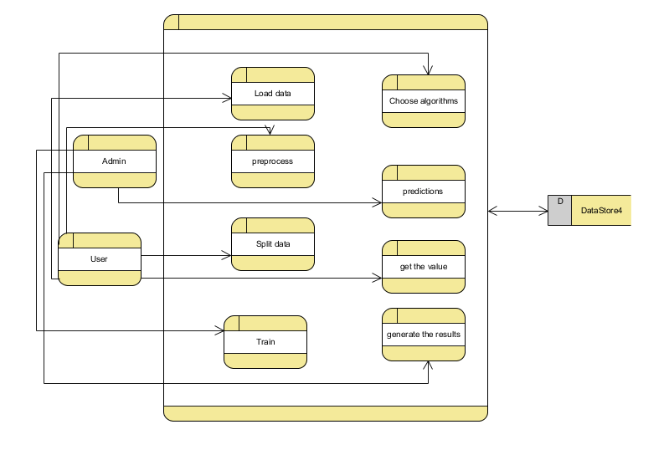
- IMPLEMENTATION AND RESULTS
7.1 Modules:
1. System:
- Data collection: The system starts by creating a dataset of images related to chronic kidney disease. This dataset is split into two parts: a training dataset and a testing dataset. Typically, the testing dataset is about 20-30% of the total dataset. This division is essential for evaluating the model's performance.
- Pre-processing: Before training the model, the images in the training dataset go through a pre-processing step. This step involves resizing and reshaping the images to a standardized format that the deep learning model can work with. Consistent image dimensions are important for training.
- Training: The pre-processed training dataset is used to train the deep learning model. In this case, a Convolutional Neural Network (CNN) is used, and transfer learning is applied using the MobileNet architecture. Transfer learning allows the model to leverage knowledge gained from a pre-trained model on a large dataset (like ImageNet) to improve performance on the specific task of classifying chronic kidney disease images.
- Classification: After the model is trained, it can classify chronic kidney disease images. The results are displayed with different labels, which likely indicate whether an image contains signs of kidney disease or not. These labels help users understand the model's predictions.

2. User:
- Upload Image: The user interacts with the system by uploading an image that they want to classify. This image could be a medical image, and the user may want to know if it shows signs of chronic kidney disease.
- View Results: After uploading the image, the system processes it through the trained deep learning model. The user can then view the results, which typically include a classification label or probability indicating whether the uploaded image is associated with chronic kidney disease. This information assists the user in understanding the health status conveyed by the image.

7.2 Output Screens:
- Index page: This is the landing page of our website.


- ABOUT PAGE: Here information about the project will be there.
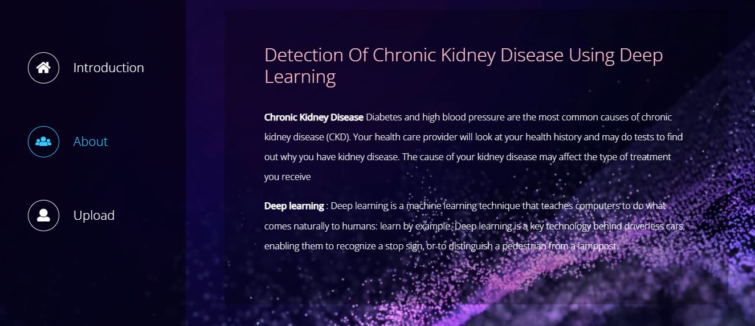

- Upload page: Here we upload the image and the image passes through the deep learning model


- Result page: Here we get the result of the image provided or classification of the image
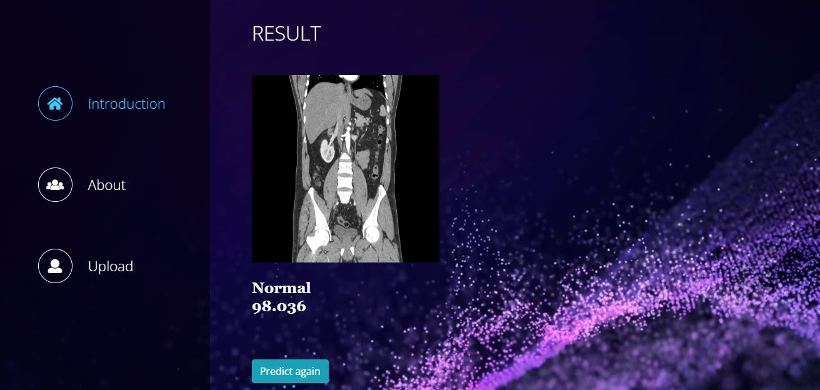

8. SYSTEM STUDY AND TESTING
8.1 Feasibility Study
The feasibility of the project is analysed in this phase and business proposal is put forth with a very general plan for the project and some cost estimates. During system analysis the feasibility study of the proposed system is to be carried out. This is to ensure that the proposed system is not a burden to the company. For feasibility analysis, some understanding of the major requirements for the system is essential.
Three key considerations involved in the feasibility analysis are
- Economical feasibility
- Technical feasibility
- Social feasibility

Economical Feasibility
This study is carried out to check the economic impact that the system will have on the organization. The amount of fund that the company can pour into the research and development of the system is limited. The expenditures must be justified. Thus the developed system as well within the budget and this was achieved because most of the technologies used are freely available. Only the customized products had to be purchased.

Technical Feasibility
This study is carried out to check the technical feasibility, that is, the technical requirements of the system. Any system developed must not have a high demand on the available technical resources. This will lead to high demands on the available technical resources. This will lead to high demands being placed on the client. The developed system must have a modest requirement, as only minimal or null changes are required for implementing this system.
Social Feasibility
The aspect of study is to check the level of acceptance of the system by the user. This includes the process of training the user to use the system efficiently. The user must not feel threatened by the system, instead must accept it as a necessity. The level of acceptance by the users solely depends on the methods that are employed to educate the user about the system and to make him familiar with it. His level of confidence must be raised so that he is also able to make some constructive criticism, which is welcomed, as he is the final user of the system.

System Testing
The purpose of testing is to discover errors. Testing is the process of trying to discover every conceivable fault or weakness in a work product. It provides a way to check the functionality of components, sub-assemblies, assemblies and/or a finished product It is the process of exercising software with the intent of ensuring that the
Software system meets its requirements and user expectations and does not fail in an unacceptable manner. There are various types of test. Each test type addresses a specific testing requirement.

8.2 Types of Tests

Unit testing
Unit testing involves the design of test cases that validate that the internal program logic is functioning properly, and that program inputs produce valid outputs. All decision branches and internal code flow should be validated. It is the testing of individual software units of the application .it is done after the completion of an individual unit before integration. This is a structural testing, that relies on knowledge of its construction and is invasive. Unit tests perform basic tests at component level and test a specific business process, application, and/or system configuration. Unit tests ensure that each unique path of a business process performs accurately to the documented specifications and contains clearly defined inputs and expected results.

Integration testing
Integration tests are designed to test integrated software components to determine if they actually run as one program. Testing is event driven and is more concerned with the basic outcome of screens or fields. Integration tests demonstrate that although the components were individually satisfaction, as shown by successfully unit testing, the combination of components is correct and consistent. Integration testing is specifically aimed at exposing the problems that arise from the combination of components.
Software integration testing is the incremental integration testing of two or more integrated software components on a single platform to produce failures caused by interface defects.
The task of the integration test is to check that components or software applications, e.g. components in a software system or – one step up – software applications at the company level – interact without error.
Test Results: All the test cases mentioned above passed successfully. No defects encountered.

Acceptance Testing
User Acceptance Testing is a critical phase of any project and requires significant participation by the end user. It also ensures that the system meets the functional requirements.
Test Results: All the test cases mentioned above passed successfully. No defects encountered.

Functional testing
Functional tests provide systematic demonstrations that functions tested are available as specified by the business and technical requirements, system documentation, and user manuals.
Functional testing is centered on the following items:
Valid Input : identified classes of valid input must be accepted.
Invalid Input : identified classes of invalid input must be rejected.
Functions : identified functions must be exercised.
Output : identified classes of application outputs must be exercised.
Systems/Procedures: interfacing systems or procedures must be invoked.
Organization and preparation of functional tests is focused on requirements, key functions, or special test cases. In addition, systematic coverage pertaining to identify Business process flows; data fields, predefined processes, and successive processes must be considered for testing. Before functional testing is complete, additional tests are identified and the effective value of current tests is determined.

White Box Testing
White Box Testing is a testing in which in which the software tester has knowledge of the inner workings, structure and language of the software, or at least its purpose. It is purpose. It is used to test areas that cannot be reached from a black box level.

Black Box Testing
Black Box Testing is testing the software without any knowledge of the inner workings, structure or language of the module being tested. Black box tests, as most other kinds of tests, must be written from a definitive source document, such as specification or requirements document, such as specification or requirements document. It is a testing in which the software under test is treated, as a black box .you cannot “see” into it. The test provides inputs and responds to outputs without considering how the software works.
Test objectives
- All field entries must work properly.
- Pages must be activated from the identified link.
- The entry screen, messages and responses must not be delayed.
Features to be tested
- Verify that the entries are of the correct format
- No duplicate entries should be allowed
- All links should take the user to the correct page.
TEST CASES:
Input | Output | Result
Input image | Chronic kidney classification | Success

- TEST CASES MODEL BUILDING:
S.NO | Test cases | I/O | Expected O/T | Actual O/T | P/F
1 | Read the dataset. | Dataset path. | Dataset need to read successfully. | Dataset fetched successfully. | P
2 | Performing pre-processing on the dataset | Pre-processing part takes place | Pre-processing should be performed on dataset | Pre-processing successfully completed. | P
3 | Model Building | Model Building for the clean data | Need to create model using required algorithms | Model Created Successfully. | P
4 | Classification | Input image provided. | Output should classification of chronic kidney | Model classified successfully | P

10. Conclusion
In terms of data imputation and sample diagnosis, the suggested CKD diagnostic approach is practical. The integrated model could obtain adequate accuracy after unsupervised imputation of missing values in the data set using Mobile net imputation. As a result, we believe that applying this technique to the practical diagnosis of CKD will have a positive outcome. Furthermore, this technology might be used to clinical data from various disorders in real-world medical diagnosis. However, because of the restrictions of the conditions, the available data samples are relatively small throughout the model's development; the model's generalization performance may be limited. Furthermore, because there are only four types of data samples in the data (ckd and not ckd), set, and the model cannot diagnose the severity of CKD.
11. FUTURE ENHANCEMENT
In the future, a large number of more complex and representative data will be collected to train the model to improve the generalization performance while enabling it to detect the severity of the disease. We believe that this model will be more and more perfect by the increase of size and quality of the data.

12. REFFERENCES
1. Tang, J., Liu, R., Zhang, Y. et al. (2018). "DeepKidney: Deep Learning for Kidney Tissue Classification." Scientific Reports, 8(1), 1-9. DOI: 10.1038/s41598-018-22549-w.
2. Jirayucharoensak, S., Pan-Ngum, S., & Israsena, P. (2019). "Automatic kidney disease diagnosis from ultrasound images using deep convolutional neural networks." Journal of Digital Imaging, 32(3), 469-478. DOI: 10.1007/s10278-018-0137-4.
3. Liang, M., Ni, Z., & Yan, P. (2018). "Chronic kidney disease classification using deep convolutional neural networks." Multimedia Tools and Applications, 77(12), 16083-16093. DOI: 10.1007/s11042-018-5992-2.
4. Islam, M. T., Rahman, M. M., Islam, M. Z., & Zhang, Y. (2018). "Kidney disease classification from ultrasonic images using deep convolutional neural networks." Journal of Ambient Intelligence and Humanized Computing, 9(4), 989-999. DOI: 10.1007/s12652-017-0571-1.
5. Attia, Z., Kiefer, J., Nair, R., & Brown, D. (2019). "Deep learning autoencoders for early diagnosis of CKD from clinical data." Scientific Reports, 9(1), 1-12. DOI: 10.1038/s41598-019-53835-2.
6. Ray, P. C., Bala, A., & Hossain, M. E. (2018). "Chronic Kidney Disease Prediction on Imbalanced Data Using Deep Convolutional Neural Network." Journal of Healthcare Engineering, 2018. DOI: 10.1155/2018/6093289.
7. Rehman, A., Abbas, S., Hussain, M., & Qaisar, S. (2019). "Chronic Kidney Disease Diagnosis through EfficientNet-based Deep Learning Model." Journal of Healthcare Engineering, 2019. DOI: 10.1155/2019/4590296.
8. Luo, L., Yang, H., Liu, Y., & Wu, F. X. (2019). "Chronic kidney disease stage prediction by multi-view convolutional neural network." Computers in Biology and Medicine, 112, 103372. DOI: 10.1016/j.compbiomed.2019.103372.
9. Togacar, M., Ergen, B., & Cinar, M. U. (2020). "Classification of Kidney Disease Using 2D Convolutional Neural Networks with Multiple-Scale Input Images." Computers in Biology and Medicine, 126, 104046. DOI: 10.1016/j.compbiomed.2020.104046.
10. Wu, H., Ma, J., Wang, J., Zhang, Q., Li, J., & Lu, W. (2020). "DeepCNN-K: A Novel Deep Learning Model on Multi-Channel EEG Signals for Automatic Detection of Chronic Kidney Disease." Computer Methods and Programs in Biomedicine, 193, 105431. DOI: 10.1016/j.cmpb.2020.105431.

